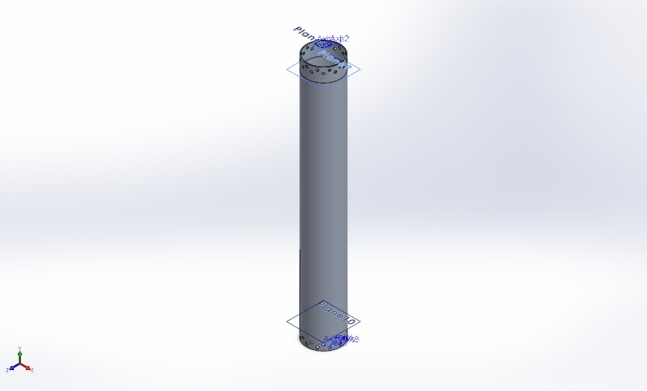
  Simulation of LOX Tank
  Date: Thursday, January 15, 2026
  Designer: Solidworks
  Study name: Static 1 with Thermal
  Analysis type: Static
  Table of Contents
  Description 1
  Assumptions 2
  Model Information 2
  Study Properties 3
  Units 3
  Material Properties 4
  Loads and Fixtures 5
  Connector Definitions 6
  Interaction Information 6
  Mesh information 7
  Sensor Details 8
  Resultant Forces 9
  Beams 9
  Study Results 10
  Conclusion 12

Description
No Data

Assumptions

Model Information

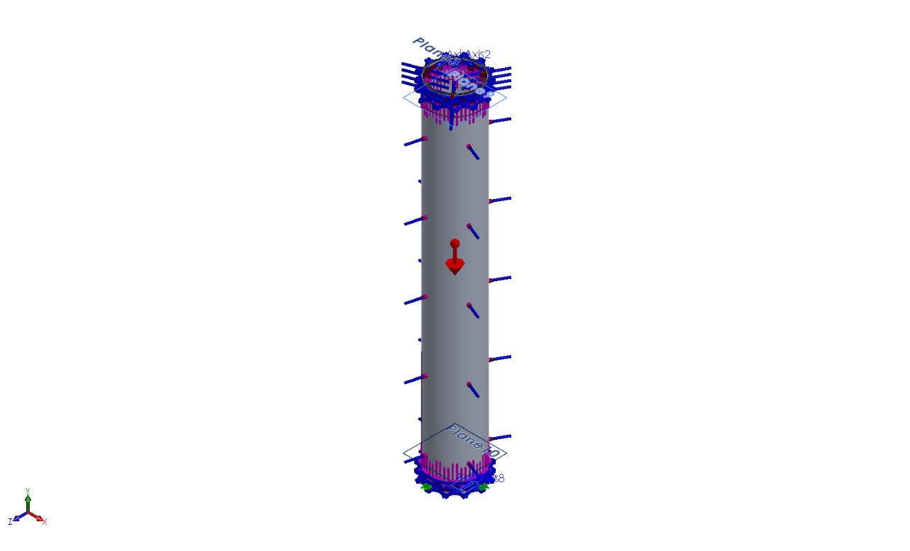
Model name: LOX Tank
Current Configuration: Default
Solid Bodies
Document Name and Reference | Treated As | Volumetric Properties | Document Path/Date Modified
Split Line12  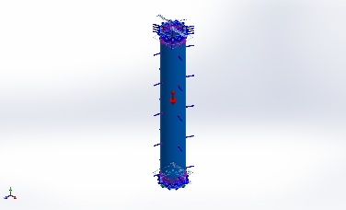 | Solid Body | Mass:4.45856 kg  Volume:0.00165132 m^3  Density:2,700 kg/m^3  Weight:43.6939 N | C:\Users\starw\OneDrive\Documents\Capstone\liquid-KeroLOX-2026\CAD\Propellant Tanks\LOX-Tank-Assem\LOX Tank.SLDPRT  Jan 13 18:39:44 2026

Study Properties
Study name | Static 1 with Thermal
Analysis type | Static
Mesh type | Solid Mesh
Thermal Effect: | On
Thermal option | Include temperature loads
Zero strain temperature | 298 Kelvin
Include fluid pressure effects from SOLIDWORKS Flow Simulation | Off
Solver type | Automatic
Inplane Effect: | Off
Soft Spring: | Off
Inertial Relief: | Off
Incompatible bonding options | Automatic
Large displacement | On
Compute free body forces | On
Friction | Off
Use Adaptive Method: | Off
Result folder | SOLIDWORKS document (C:\Users\starw\OneDrive\Documents\Capstone\liquid-KeroLOX-2026\CAD\Propellant Tanks\LOX-Tank-Assem)

Units
Unit system: | SI (MKS)
Length/Displacement | mm
Temperature | Kelvin
Angular velocity | Rad/sec
Pressure/Stress | N/m^2

Material Properties
Model Reference | Properties | Components
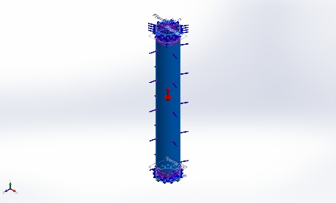 |  | SolidBody 1(Split Line12)(LOX Tank)
  Name: | 6061-T6 (SS)
  Model type: | Linear Elastic Isotropic
  Default failure criterion: | Unknown
  Yield strength: | 2.75e+08 N/m^2
  Tensile strength: | 3.1e+08 N/m^2
  Elastic modulus: | 6.9e+10 N/m^2
  Poisson's ratio: | 0.33
  Mass density: | 2,700 kg/m^3
  Shear modulus: | 2.6e+10 N/m^2
  Thermal expansion coefficient: | 2.4e-05 /Kelvin
Curve Data:N/A

Loads and Fixtures
Fixture name | Fixture Image | Fixture Details
Roller/Slider-5 | 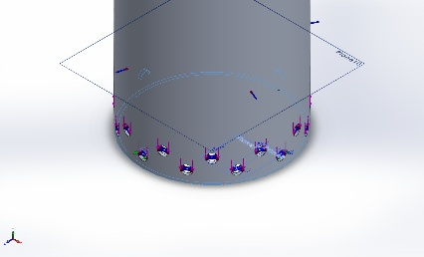
  Entities: | 5 face(s)
  Type: | Roller/Slider
Resultant Forces
Components | X | Y | Z | Resultant
Reaction force(N) | -0.110168 | 395.361 | 0.884583 | 395.362
Reaction Moment(N.m) | 0 | 0 | 0 | 0

Load name | Load Image | Load Details
Force-1 | 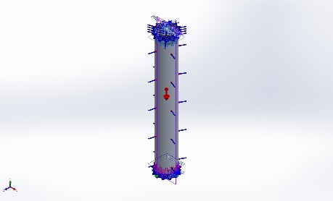
  Entities: | 24 face(s), 1 plane(s)
  Reference: | Front Plane
  Type: | Apply force
  Values: | ---, 17,000, --- lbf
Force-2 | 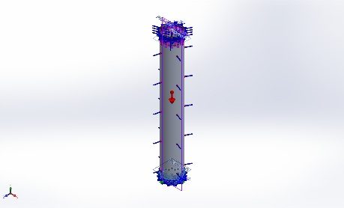
  Entities: | 24 face(s), 1 plane(s)
  Reference: | Front Plane
  Type: | Apply force
  Values: | ---, -17,000, --- lbf
Temperature-1 | 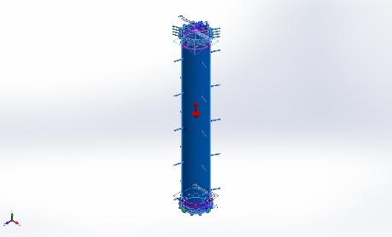
  Entities: | 103 face(s)
  Temperature: | -300 Fahrenheit
Gravity-1 | 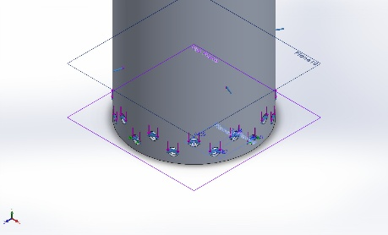
  Reference: | Top Plane
  Values: | 0 0 -88.29
  Units: | m/s^2
Pressure-2 | 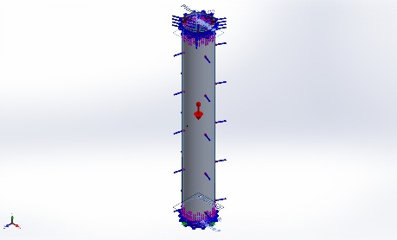
  Entities: | 1 face(s)
  Type: | Normal to selected face
  Value: | 600
  Units: | psi
  Phase Angle: | 0
  Units: | deg

Connector Definitions
No Data

Interaction Information
No Data

Mesh information
Mesh type | Solid Mesh
Mesher Used: | Blended curvature-based mesh
Jacobian points for High quality mesh | 16 Points
Maximum element size | 0.806082 in
Minimum element size | 0.0759627 in
Mesh Quality | High

Mesh information - Details
Total Nodes | 98190
Total Elements | 45304
Maximum Aspect Ratio | 10.61
% of elements with Aspect Ratio < 3 | 31.2
Percentage of elements with Aspect Ratio > 10 | 0.00441
Percentage of distorted elements | 0
Time to complete mesh(hh;mm;ss): | 00:00:10
Computer name: | CHARLES

Mesh Control Information:
Mesh Control Name | Mesh Control Image | Mesh Control Details
Control-2 | 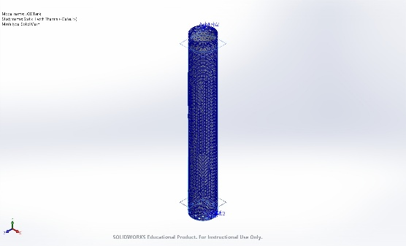
  Entities: | 1 face(s)
  Units: | in
  Size: | 0.236787
  Ratio: | 0.236787

Mesh Quality Plots
Name | Type | Min | Max
Quality1 | Mesh | - | -
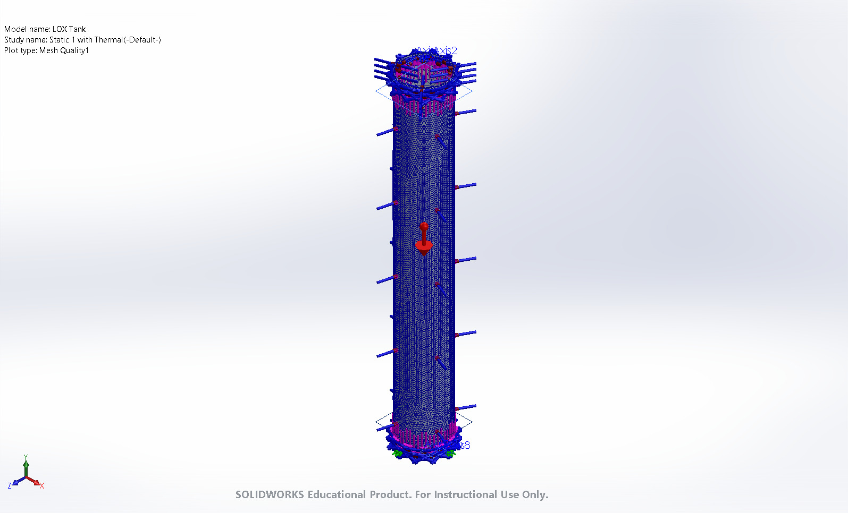
LOX Tank-Static 1 with Thermal-Quality-Quality1

Sensor Details
No Data

Resultant Forces

Reaction forces
Selection set | Units | Sum X | Sum Y | Sum Z | Resultant
Entire Model | N | -0.110168 | 395.361 | 0.884583 | 395.362

Reaction Moments
Selection set | Units | Sum X | Sum Y | Sum Z | Resultant
Entire Model | N.m | 0 | 0 | 0 | 0

Free body forces
Selection set | Units | Sum X | Sum Y | Sum Z | Resultant
Entire Model | N | 0 | 0 | 0 | 0

Free body moments
Selection set | Units | Sum X | Sum Y | Sum Z | Resultant
Entire Model | N.m | 0 | 0 | 0 | 0

Beams
No Data

Study Results

Name | Type | Min | Max
Stress1 | VON: von Mises Stress | 1.406e+03psi  Node: 74080 | 9.148e+04psi  Node: 82273
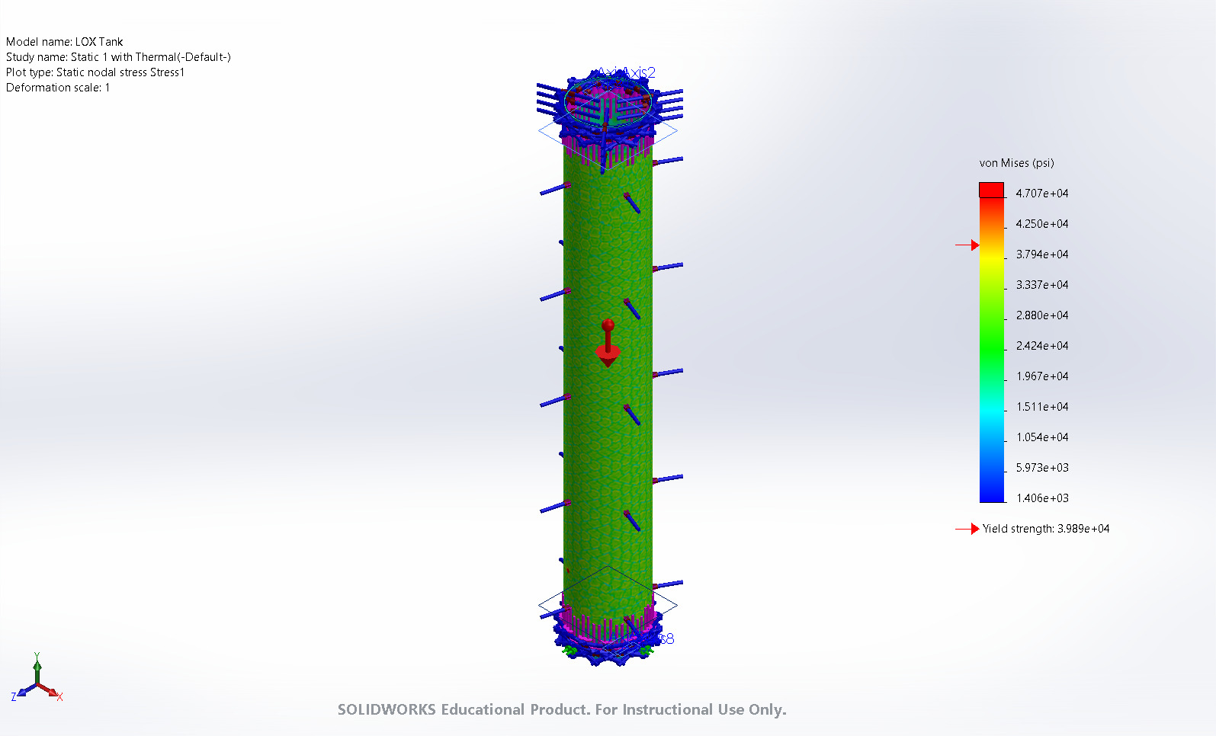
LOX Tank-Static 1 with Thermal-Stress-Stress1

Name | Type | Min | Max
Displacement1 | URES: Resultant Displacement | 1.167e-03mm  Node: 54863 | 1.517e+00mm  Node: 25728
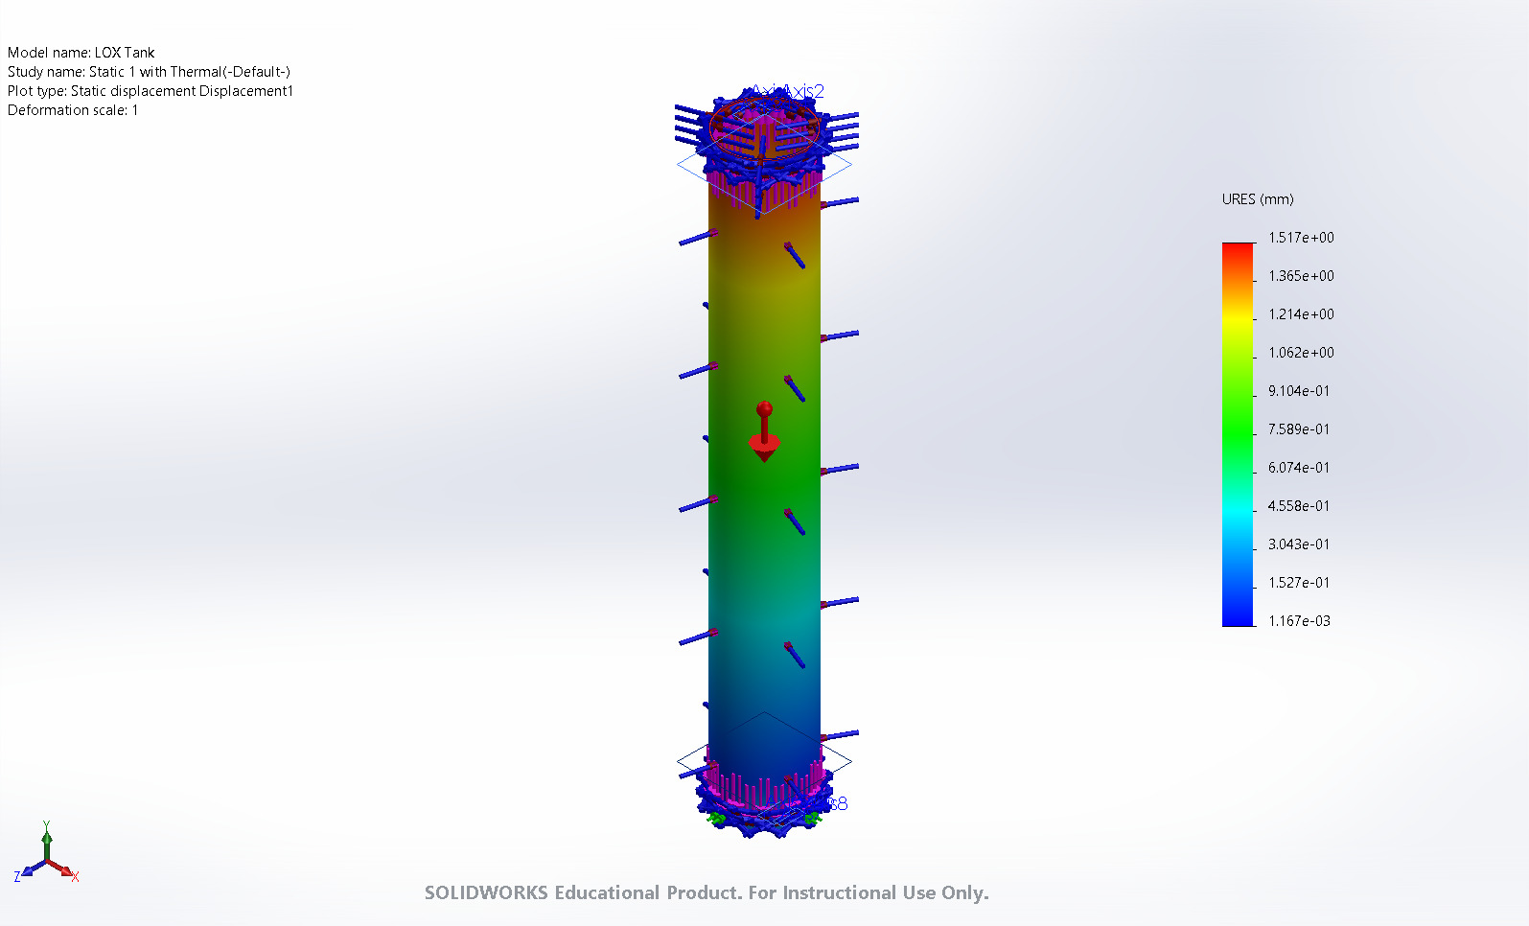
LOX Tank-Static 1 with Thermal-Displacement-Displacement1

Name | Type | Min | Max
Strain1 | ESTRN: Equivalent Strain | 5.595e-05  Element: 1372 | 4.732e-03  Element: 2599
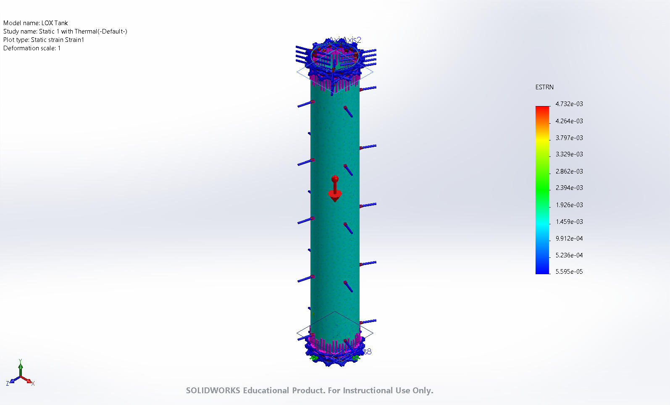
LOX Tank-Static 1 with Thermal-Strain-Strain1

Conclusion

